Ex.No. 2: Implementing TDMA Slot Allocation in GSM.

AIM: To implement TDMA (Time Division Multiple Access) slot allocation in GSM using MATLAB and analyze system performance in terms of time slot duration, frame utilization, and number of allocated slots.
Objective:
- To calculate the Time Slot Duration in a GSM TDMA frame by dividing the total frame time into equal time slots. This helps in understanding the time structure of GSM communication.
- To determine the Frame Utilization (%) based on the number of allocated time slots compared to total available slots. This evaluates the efficiency of TDMA resource usage.
- To compute the Number of Allocated Time Slots for multiple users in the GSM system. This ensures proper scheduling and interference-free communication.
Procedure:
- Define GSM frame parameters such as total frame duration and number of time slots.
- Compute time slot duration by dividing frame duration by number of slots.
- Assign time slots to multiple users based on availability.
- Calculate frame utilization percentage using allocated slots vs total slots.
- Determine total number of allocated slots for active users.
- Plot time slot allocation and utilization using MATLAB graphs.
- Display results in the command window for analysis..

Objective 1: Matlab Code and Output
clc;
clear;
close all;

FrameTime = 4.615; % Frame duration in ms
Slots = 8; % Number of TDMA slots
SlotDuration = FrameTime / Slots;

t = 0:SlotDuration:FrameTime;

figure;

% Plot 1: TDMA Time Slot Structure
subplot(2,1,1);
stem(t, ones(size(t)), 'filled');
title('TDMA Time Slot Structure');
xlabel('Time (ms)');
ylabel('Slot Level');
grid on;

% Plot 2: Continuous View of Slot Allocation
subplot(2,1,2);
plot(t, ones(size(t)), '-o', 'LineWidth', 1.5);
title('Continuous View of Slot Allocation');
xlabel('Time (ms)');
ylabel('Slot Presence');
grid on;
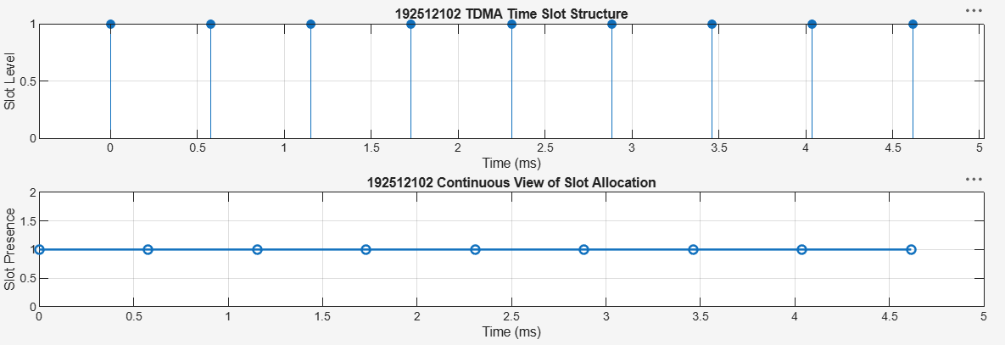
Objective 2: Matlab Code and Output
clc;
clear;
close all;

TotalSlots = 8;
AllocatedSlots = 6;
FreeSlots = TotalSlots - AllocatedSlots;
Utilization = (AllocatedSlots / TotalSlots) * 100;

disp('Frame Utilization (%)');
disp(Utilization);

figure;

% Graph 1: Allocated vs Free Slots
subplot(2,1,1);
plot([1 2], [AllocatedSlots FreeSlots], '-o', 'LineWidth', 2);
title('GSM Frame Utilization (Allocated vs Free)');
xlabel('Slot Type Index (1=Allocated, 2=Free)');
ylabel('Number of Slots');
grid on;

% Graph 2: Slot Distribution
subplot(2,1,2);
pie([AllocatedSlots FreeSlots]);
title('Slot Distribution in GSM Frame');
legend('Allocated', 'Free');
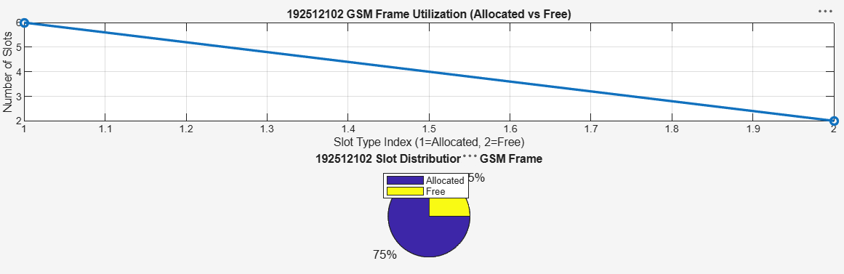
3: Matlab Code and Output
clc;
clear;
close all;

Users = 1:8; % Total users
TotalSlots = 5; % Available slots

Alloc = zeros(1,8); % Initialize allocation
Alloc(1:TotalSlots) = 1; % Assign slots to first users

Blocked = 1 - Alloc; % Remaining users blocked

disp('User Wise Slot Allocation');
disp(table(Users', Alloc', ...
'VariableNames', {'User', 'Status_1_Allocated_0_Blocked'}));

figure;

% Graph 1: Allocation per user
subplot(2,1,1);
stem(Users, Alloc, 'filled', 'LineWidth', 2);
title('TDMA Slot Allocation per User');
xlabel('User Index');
ylabel('Slot Status (1=Allocated, 0=Blocked)');
ylim([-0.2 1.2]);
grid on;

% Graph 2: System view
subplot(2,1,2);
plot(Users, Alloc, '-o', 'LineWidth', 2);
hold on;
plot(Users, Blocked, '-s', 'LineWidth', 2);
title('TDMA Slot Utilization Analysis');
xlabel('User Index');
ylabel('Status');
legend('Allocated', 'Blocked');
grid on;
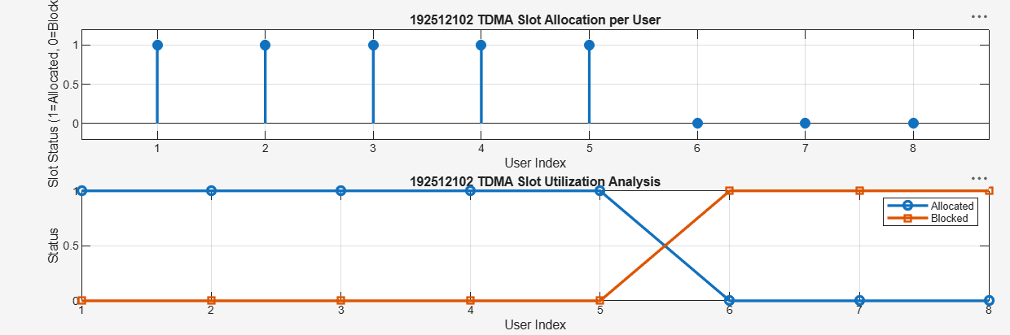
Result:
- The time slot duration in the GSM TDMA frame was successfully calculated, confirming equal division of the frame into fixed time intervals.
- The frame utilization was effectively analyzed, showing the proportion of allocated and free slots in the TDMA system.
- The slot allocation per user was successfully implemented, demonstrating that limited slots are assigned to users while excess users are blocked due to resource constraints.

